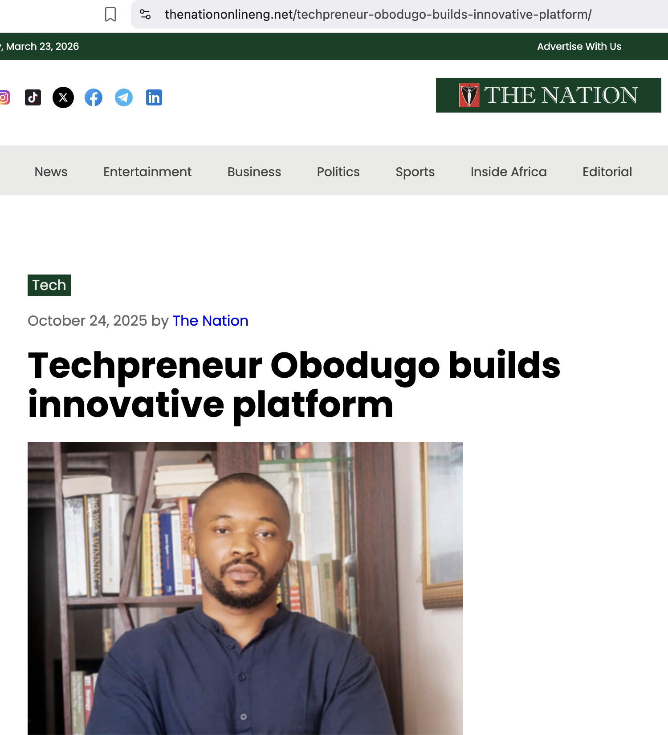
https://thenationonlineng.net/techpreneur-obodugo-builds-innovative-platform/



